

# **Condingup Primary School**

**Newsletter**

Friday, 1st May 2020 | Week 1 Term 2

[condingup.ps@education.wa.edu.au](mailto:condingup.ps@education.wa.edu.au)

[*www.condingupps.wa.edu.au*](http://www.condingupps.wa.edu.au)

Telephone: 9076 6013

Telephone: 9076 6013

**Principal’s Letter**

To Parents,

The sound of students playing together in the playground and the laughter as they catch up with friends is very warming as we start the new Term. It was a little bit lonely around the place at the end of last term. We all missed having the students around and shaping their education. If you haven’t had a chance to see it yet, be sure to watch the YouTube clip we put together at the end of last term. It was lots of fun to film and Mr Jake did an incredible job putting it all together. The link for the clip is: <https://youtu.be/K1BPsJfZvS0>

Although we are in uncertain times, Education in WA is open and this is being rolled out through a multimodal approach. Some of our families are being supported at home with our incredible Connected Learning design, and those students who have returned to school are getting a quality education program delivered by their teachers. Currently the lessons being delivered look very similar for the students at home and the students at school. Our aim is to have the two programs running side by side so that the transition from home to school can be as smooth as possible.

**SEESAW**

Although students have returned to school, we will still maintain the Condingup Families SEESAW journal. There is currently a task on the journal for all students to participate in. A number of students have sent us a dance move and the incredible Mr Jake has choreographed all of these moves into a dance. Families are encouraged to learn the dance together and to upload their video on to the blog. At the end of last term, it was great to see the positivity that this page brought to staff and students as they were isolating. Let’s continue with this to ensure that we all stay connected.

**COVID-19 Update**

The WA Government, along with the department of Education have outlined a number of guidelines for schools to follow regarding cleaning and preventing the spread as advised by the AHPPC. As part of this we have implemented a number of processes at Condingup PS. These include the following:

* Minimise activities that involve mixing between classes and years. Reduce the use of common areas.
* Where possible, avoiding close-proximity queuing and encouraging increased space between students
* Cancel excursions, assemblies, sporting activities, and other large gatherings.
* Where possible conduct lessons outdoors or in environments with enhanced ventilation
* Arrange classrooms to leave as much space as possible between students
* Maintain smaller classes
* Avoid group work
* Student work being submitted electronically, where feasible
* Student work being handed to a teacher for feedback rather than feedback being provided immediately by the teacher in close proximity to the student.

We have increased the hours of our cleaners to ensure that we have a cleaner on site throughout the day. This will allow the opportunity to clean the classrooms, high surface areas and playgrounds regularly throughout the day; preventing the spread and working towards ensuring the safety of our students.

**Sick Students**

We are asking you all to be mindful of the other students and to keep your child/ren at home if they are unwell. If your child is sick, they must not go to school. You must keep them at home and away from others. If a child presents as unwell to the school parents will be contacted and students sent home.

**Drop-off and Pick-up**

At this stage we are requesting for all parents to drop-off and pick-up their child from the school gates of a morning and afternoon. The school office is still open and you are welcome to come in and see us if you need. We just ask that you do not enter any other parts of the school grounds, this is to ensure the health and safety of our students and staff.

**Upcoming Events**

Currently our term planner is looking extremely bare. Although we may not be able to hold gatherings, meeting or assemblies at the moment; we are working on innovative ideas to keep school life at Condingup PS engaging and to provide opportunities for us to celebrate our students and their achievements. Watch this space, there is more information to come.

Remember to keep updated with the school and the information sent home to parents. Regularly check your child’s diary, the skoolbag app, the website and emails. We look forward to Term 2 and what it might bring. Currently in education and in the world in general we are navigating in uncertain times. Although this experience is often daunting for us all it can also be an exciting time. How will our experiences in this moment shape our future and the future of education?

Kind regards,

Krystal Wiggins

Principal

**Councillors Report**

Welcome back to Term Two. At school everyone is having a great time playing Andy, Andy Over or playing on the pirate ship playground. We have the K/P/1’s in Miss McWillam’s class and the year 2’s to 6’s are in Miss Worth’s and Miss Stirk’s class for the week. The year 6’s have done an ANZAC Poem and speech over the PA system so everyone in the school can participate in a minute silence. Lest We Forget. We hope to see more students back at school next week and we hope everyone stays safe.

By Beau and Alice

**ANZAC Day Tribute**

On Thursday the students spent the whole day learning about ANZAC Day. They participated in a range of activities learning about the important history, symbols and values that we reflect on and commemorate.

Our pre-primary, year 1 and year 2 students wrote a poem that they would like to share:

Soldiers went to war.

No-one knows what they saw.

They climbed up the cliff.

They felt very stiff.

The Soldiers were sad.

When war ended they were glad.

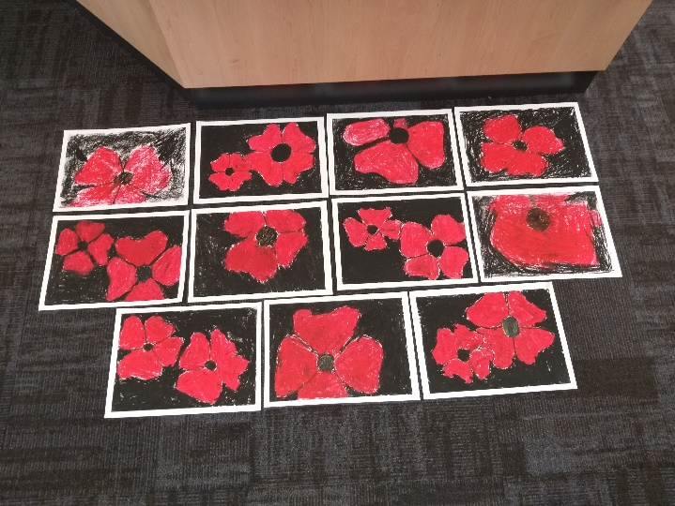

**For the afternoon the P-2’s completed a ‘Poppy drawing’ art piece using chalk to honour our fallen soldiers.**



**The years 3-6’s completed an art piece with inspiration from dawn services by creating a sunrise effect. They added silhouettes to commemorate our ANZAC soldiers.**

**Book Club Virtual Catalogue – Issue 3, 2020**

Term 2 Book Club catalogues are digital only (no paper catalogues) this term for the first time ever during these unprecedented times. To access and purchase from the latest Issue, please go to [https://scholastic.com.au/book-club/virtual-catalogue-1/](https://aus01.safelinks.protection.outlook.com/?url=https%3A%2F%2Fscholastic.com.au%2Fbook-club%2Fvirtual-catalogue-1%2F&data=02%7C01%7CJustine.K.McDonald%40education.wa.edu.au%7C0a9347c5e44249f90db208d7ecbcdf38%7Ce08016f9d1fd4cbb83b0b76eb4361627%7C0%7C0%7C637238168282085506&sdata=U0NuCQd671vXbSYgrb5eNh5Darpjbiy8vyl6jkaMFvE%3D&reserved=0) We encourage you to sit down with your child and go through the catalogue together, discussing any books that sparks your child’s interest.

Once you and your child has made your final selection, click anywhere on the page to redirect you to the Scholastic LOOP website or go to the Scholastic LOOP app to place your order. LOOP orders are linked to your school in an easy, safe online process. Registering for LOOP will also keep you up-to-date with all of the latest Book Club news, information on exciting new releases, and our exclusive Book Club special offers.

Our Book Club Organiser will then take care of the rest! After everyone’s orders is submitted by the suggested close date of Issue of XX May 2020, the Scholastic team get to work packing your child’s order full of exciting things.

Your child’s order is then delivered to the school/classroom, ready to take home and be eagerly read. If our regular Book Club order distribution procedure need to be adapted, an electronic announcement will be made. Orders that you have marked as a ‘gift’ in LOOP will be sent to school for you to secretly pick-up instead.

**Please have your orders submitted by 18th May 2020.**



**Community News**

The Condingup Community Centre will be receiving its annual pest control treatment on Wednesday 6th May.  The Shire of Esperance has asked that no one accesses the centre on this day due to the active ingredients used in the treatment.