Condingup Primary School
Newsletter

Friday 27th November 2020 | Week 7 Term 4

condingup.ps@education.wa.edu.au
www.condingupps.wa.edu.au

Telephone: 9076 6013

Telephone: 9076 6013

Principal’s Letter

The school is a hive of activity as students and teachers finalise the teaching and learning tasks for 2020. Along with this, preparations for the end of year concert and the transition days for high school make for a hectic schedule.
School Council
Last week saw the final meeting of the School Council for 2020. The Council’s fundamental purpose is enabling parents and members of the community to provide feedback on the school’s operations and procedures to enhance the education provided by the school. Being a member of a council is an essential and rewarding role that contributes significantly to the success of a school. Members include the principal, parents, staff, and others from the wider community who can lend their skills and expertise to the school.
I need to thank the members who are leaving or stepping down from roles on the Council. A big thank you to Marie Fowler, who has been the School Council Chairperson. Marie has done an excellent job, and the members are pleased that she will stay on as a community member in 2021. I want to welcome Kris Perks as the new Chairperson, her diligence and enthusiasm for our school will be a fantastic asset. Finally, I must say thank you and farewell to Ian MacKenzie and Bec Hoggart. Thank you for your commitment to Condingup Primary School. In their place, we have Ashleigh Batley (one year) and Deb Greene (three years). The School Council looks forward to their future contributions.
Transition Day
Today saw the last of the Transition Days for Esperance based high schools. Esperance Senior High School had a fantastic day planned for the students, and I am sure the design and technology rooms and activities will be a highlight. Brett Landers, the year coordinator, met all the Mallee students as they assembled in the main quadrangle

and the principal Ian Masarei gave the students a warm welcome. I look forward to hearing the great stories from their induction.
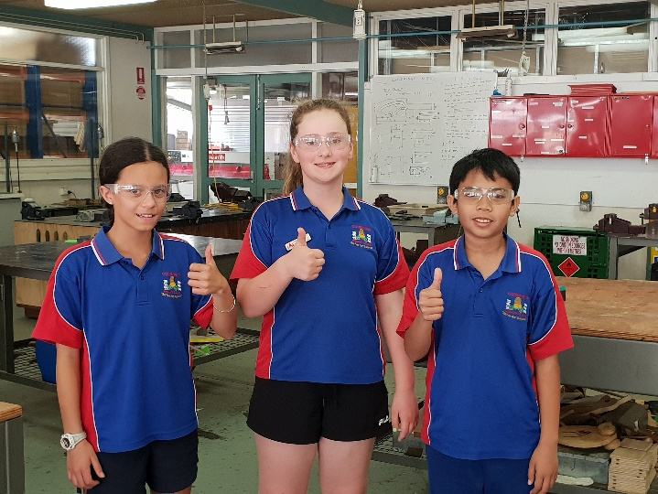
Transition and Graduation Day
Next Friday (December 4th) is the Year 6 student Grad Day in Esperance. The students have a day full of adventure at the Bay of Isles Leisure Centre and the Esperance Lawn Bowls. While the Year 6 students are away, we will be running the transition day. Of particular importance is the Kindy Transition. I look forward to meeting our new parents as you spend time with your Kindy aged children in the classroom, followed by an information session for the parents.
Kind regards,
Paul Jefferies
School Information

CPS Canteen Term 4
Please make sure your child/ren’s name, year and the total cost of the order has been recorded on the order bag. This makes life much easier for the canteen volunteer on the day! Thank you!
This term there will be STRAWBERRY Bulla Frozen Yoghurt Cups.

Term 4

4th December – Marlize Breed
11th December – Anita Chalmer

The Condy - Celebration of Success

The following students have achieved award
recognition from their teachers:

Paisley Hoggart Jonty Ruddenklau
Niamh Murphy Harley Bingham
Stella Greene Beau Taylor

Councillors Report

Last week a few of the Year 6’s went away to the EACS transition day. They had to do lots of tests but we all got to meet some new friends as well. Today was also the ESHS transition day, we hope they have a great day. Three of us that are going to school in Perth next year have had our transition days lately too. In the playground the younger kids have been playing cricket and it is nice to see their great sportsmanship when someone gets out or makes a run. The senior students have also been playing bump in the playground or playing with the younger students. I’m looking forward to the holidays and I hope you all have a good week.
By Alice and Beau
Treasurer Hunters Club

Would anyone like to join the team that runs Treasurer Hunters Club?

We meet every Wednesday for half an hour at lunch time, having fun with the kids.

Please phone one of the ladies below if you are interested:
Marie 0427 750 047
Candy 0487 137 698
Mary 0419 766 167

As we come to another wonderful year of Treasure Hunters Club, we as Club leaders want to thank all the dedicated children who join us every Wednesday for fun activities.
Some new leaders have joined our team, and we want to thank Christy (Youth Care Field Officer) who flew from Perth to provide us with training.

She got us all excited and ready for the lessons and values we will be teaching the children next year.
We thought the parents would like to be informed about what’s happening at Treasure Hunters, so we will share some pictures and stories next time. Watch this space….
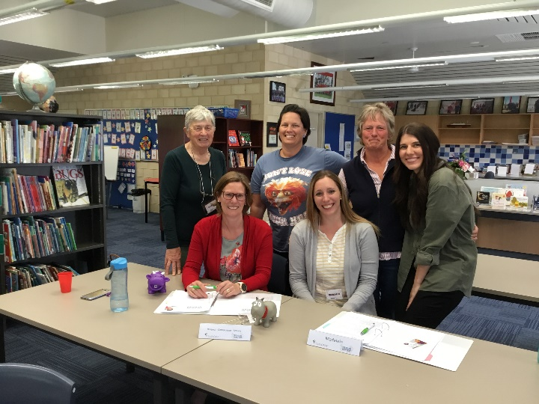

Important Term 4 Dates

Friday, 4th December – Year 6 Graduation Mallee
Day
- Kindy Transition Day

Thursday, 10th December – Year 6 Graduation
Dinner

Wednesday, 16th December – Graduation Night

Thursday, 17th December – Last day of Term for
students

CBA School Banking

Condingup Primary School is excited to offer the Commonwealth Bank School Banking program to all students.
School Banking is a fun, interactive and engaging way to help young Australians practice good savings habits. Children who deposit money into their Youthsaver account through School Banking will earn an exciting reward everytime they reach 10 deposits.
School Banking is also a great fundraiser for our school. Our school receives a Regular Savers Contribution of $5 for every 10 deposits processed per student as well as an Annual Contribution which is based on the number of students who made at least one School Banking deposit in the prior year.

CPS Uniform Update
Andrea Simpson is the new uniform coordinator for the CPS P & C Association. If you would like to purchase any uniform items, please contact Andrea on 0474 147 944 to arrange a day and time to meet her at school.
Andrea will be at school on Friday 4th December from 8:30am onwards for the 2021 Kindy students transition day if parents would like to purchase any uniforms or stock up on the items needed for 2021.
Condy Number Plates

Would you like a set of Condy number plates for your ute, car, truck or caravan? This may be your last chance to get your personalised Condy plates!
If you are interested, please contact Kara Murphy on 0427 014 883.

