**Canberra Camp 2025**

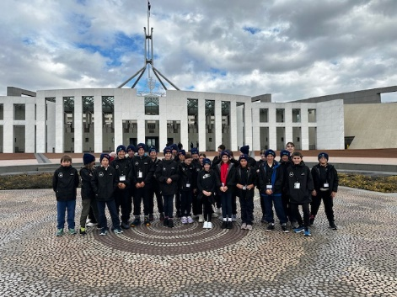It is difficult to summarise the Canberra trip as we packed in so much in one week. We can say that it was an excellent trip full of learning. We got to learn all about the Governance of Australia and voting. We had learnt so much in our Civics and Citizenships lessons and this helped consolidate our learning. Our knowledge of the democratic, historical, and cultural aspects of our capital city. We had some awe-inspiring moments, meeting the Governor General, as well as moments of reflection, in particular at the War Memorial. The first day was all travel from Perth to Sydney and then by bus down to Canberra. We arrived in the evening, exhausted but happy.

Then the real part of the trip begun, with visits to the mint, Parliament House, Old Parliament, and the AIS. Parliament House was impressive, and its size left everyone in awe. Security is taken very seriously and we were on our best behaviour. Did you know the flagpole stands 81 metres tall. We saw a Lego replica built by Ryan McNaught (“The Brickman”) We discovered that there are over 2700 clocks in parliament. There is no excuse for being late… Before we went to Canberra we had an online session with Parliament House, and Monique was the person that taught us. We were so pleased to meet her in persona and she taught us all about the passing of bills through role play. At the old parliament building, Cam, our guide, was impressed with our knowledge.

The next day we went to the EEC, The High Court (very impressive!), the NCE, the Dinosaur museum and bowling. Interesting facts…did you know it was suggested that Canberra should be called Sydmeladperbrisho? (We think that Canberra, meaning meeting place in Aboriginal language, is much better). Did you know that dinosaurs, as reptiles, cannot roar, so the movies are wrong. They are more likely to sound like a pitched down cassowary bellow. The bowling left everyone in high spirits, some children had never played before but aced it! Please ask the students about Mrs Strong and the hot chip and the decision made by the High Court.

On the Wednesday we had some incredible experiences. We started at Government House, where we were welcomed by the AFP and greeted by Captain Katie Higgins, the Army Aide-de-Camp. But before she could really start, Her Excellency The Honourable Ms Sam Mostyn AC, the Governor-General of Australia, stepped out from behind a curtain! She spoke with us for about 15 minutes, answering questions and explaining her role. We found her friendly, warm, and down to earth. Mrs VS invited her to visit us in Esperance and the Mallee!! I wonder if she will come? We then toured the Government House grounds, official dining room, and the car ‘stables.’ We learnt so much— a truly once-in-a-lifetime experience.

Our afternoon visit to the Australian War Memorial was powerful and reflective. A guide showed us around and we learnt about many things; especially about how terrible war is. We learnt about many of the brave sacrifices made, including Nurse Rachael Pratt, who continued working after unknowingly being wounded by shrapnel in WWI. We found out about animals in the war, including the dog Gunner who was in Darwin. An interesting thing we learnt was about a German dog called Roff. He was a messenger dog. The Australian soldiers decided to entice him to their side of the war. So, by feeding him lots and petting him he switched sides and stayed with the Australians. Roff lived through the war and lived in the UK afterwards. We were pleased with the ending of that story. We felt we could have spent more time at the memorial as there is so much to learn.

To close the day, we attended a Last Post Ceremony. Sophie, along with Jim from Scaddan and Harrison from Cascade, were honoured to lay a wreath on behalf of our schools. Unbeknownst to them, they were standing beside the Prime Minister of Fiji. The top brass from the Australian Air Force were there too. We certainly felt like we were mixing with the top echelons. That aside, it was a poignant moment to reflect on the life of the fallen soldier, Lance Corporal Frank Henry Ough Dealy. As expected, all of the students showed the upmost respect for the ceremony. It is an experience that none of us will forget.

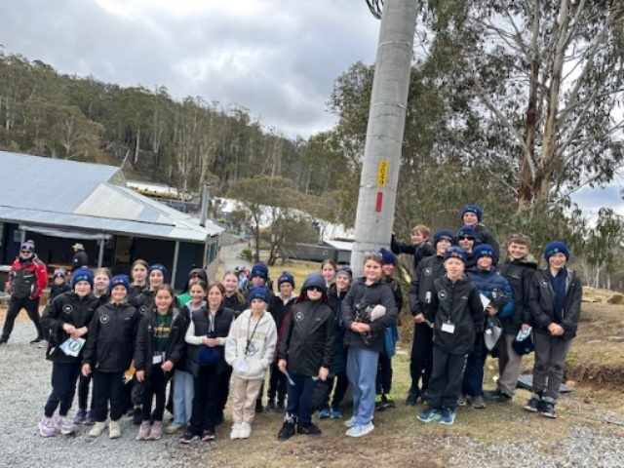Other activities that day included The Australian National Botanical Gardens, we ‘went around Australia in an hour,’ and Questacon. At Questacon, the students loved the hands-on science experiences — lightning machines, earthquake simulators, and the fan-favourite: the free-fall slide!

Later in the week we went skiing, and great fun was had by all. Our ski instructor was unwell, so we all went snowboarding instead! It was impressive to see the progress but also amusing to watch. The children kept trying, picking themselves up, laughing and smiling. It was an excellent experience. We also went to the Canberra Deep Space Complex, saw Wombats (Mrs VS got very excited about both CDSC and the wombats!), and finally went to Sydney. We were thrilled to see Bondi Beach and where the rescue tower is located. It seems many of us have watched Bondi Rescue. Seeing the bridge and the Opera house also caused a stir. Everyone loved the zoo, but tiredness really started to hit and when we got to the lions one by one children (and an adult!) started to sit down. We decided to call it a day and headed back to the bus and to the airport.

Thank you to PACER, AGFRI, CSPB and Clarke and Stokes for your support to make it happen.

What a brilliant trip, what brilliant children and what memories we made!

The Canberra Camp Crew 😊



